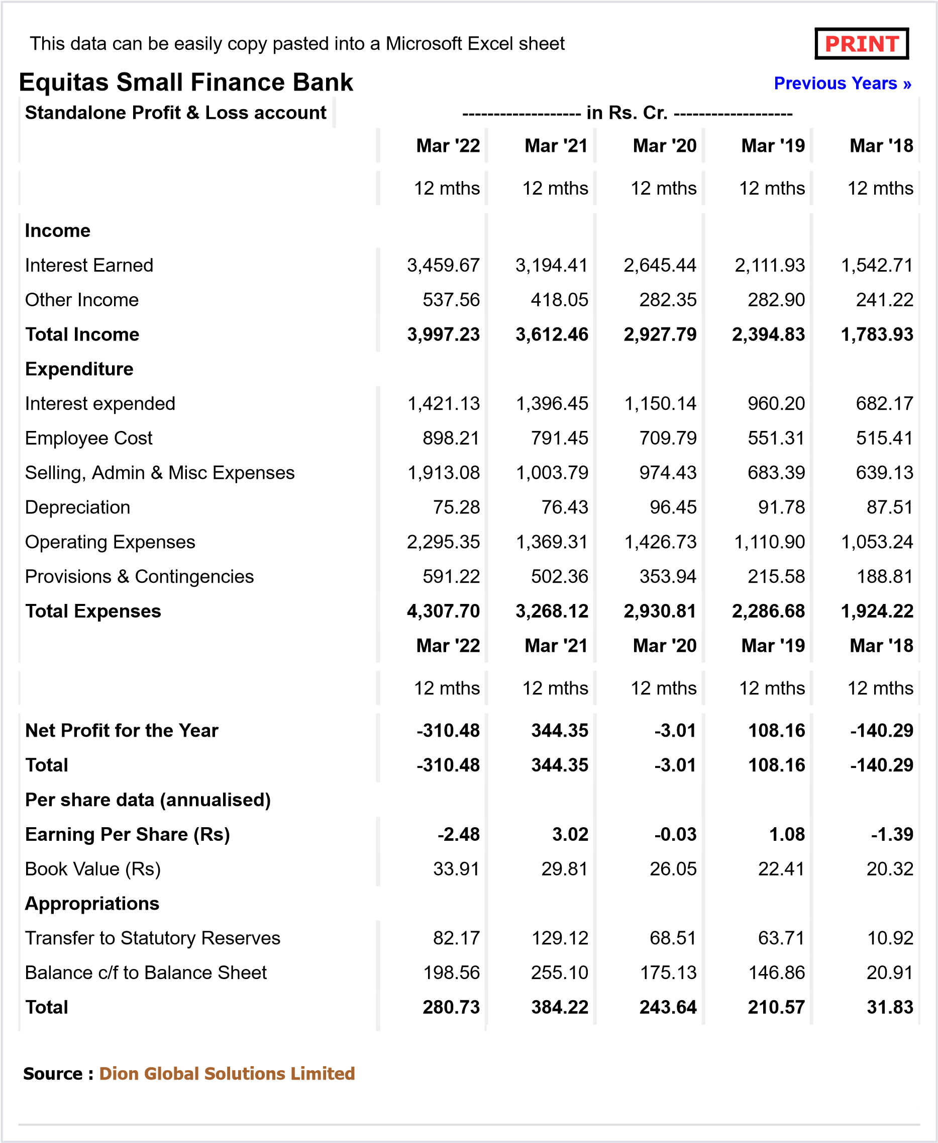

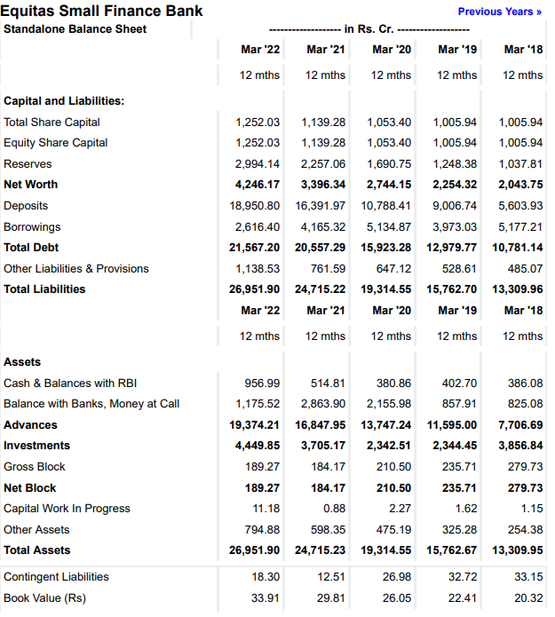

Cost of Debt (Kd)

The cost of debt is the effective interest rate that a company pays on its debts, such as bonds and loans. The cost of debt can refer to the before-tax cost of debt, which is the company's cost of debt before taking taxes into account, or the after-tax cost of debt. The cost of debt measurement is useful in understanding the overall rate of a company for paying for using these types of debt financing.

Formula

* Cost of Redeemable Debentures before tax

Kdb  *100

* Cost of Irredeemable Debentures before tax

Kdb = *100

* Cost of Redeemable Debentures after tax

Kda  *100

* Cost of Irredeemable Debentures after tax

Kda = *100

**Cost of debt calculation**

Total Interest of the company=1,421.13Cr

Borrowings=2,616.40Cr

Total debt of the company= 3534.70Cr

Cost of Irredeemable Debentures before tax

Kdb = *100

= $\frac{1,421.13}{3534.70 }$*100

= 0.06589*100

= 40.2 %

Total income of FY22 =3997.23Cr

Tax =97.37Cr

Tax rate = $\frac{3997.23}{97.37}$*100

= 0.024359*100

t = 2.43659 %

* Cost of Irredeemable Debentures after tax

Kda = *100

= $\frac{1,421.13\left(1-2.44\%\right)}{3534.70 }$*100

= $\frac{1,421.13*\left(0.9756\right)}{3534.70 }$*100

= 0.3922*100

= 39.22 %